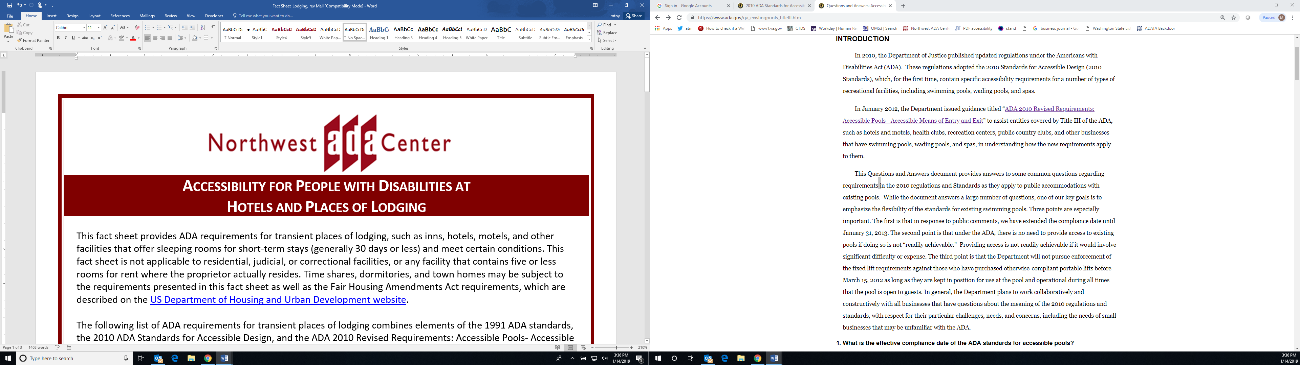

**Accessibility for People with Disabilities at**

**Hotels and Places of Lodging**

The Americans with Disabilities Act (ADA) established requirements for transient places of lodging, like hotels, motels, inns, and other facilities that offer sleeping rooms for short-term stays (generally 30 days or less) and meet certain conditions. For the purposes of this fact sheet, all such facilities will be referred to as hotels.

This fact sheet is not applicable to residential, judicial, or correctional facilities, or any facility that contains five or less rooms for rent where the proprietor actually resides. Time shares, dormitories, and town homes may be subject to the requirements presented in this fact sheet as well as the Fair Housing Amendments Act requirements, which are described on the [US Department of Housing and Urban Development website](https://www.hud.gov/program_offices/fair_housing_equal_opp/fair_housing_act_overview).

The following list of ADA requirements for hotels combines elements of the 1991 ADA standards, the 2010 ADA Standards for Accessible Design, and the ADA 2010 Revised Requirements: Accessible Pools- Accessible Means of Entry and Exit (which took effect on January 31, 2013).*

# Reservations

* Hotels are required to have accessible guest rooms (i.e. rooms with mobility features for people with physical disabilities and communication features for people who have a hearing disability). The minimum number of accessible guest rooms that a hotel must have is based on the total number of guest rooms that the hotel provides. (See tables below.)
* Guests with disabilities must be provided a range of options equivalent to the options available to other guests, so accessible guest rooms must be dispersed among the different classes of guest rooms available in the hotel, including bed size, non-smoking, smoking, views, costs, etc.
* Persons with disabilities must be able to reserve accessible guest rooms during the same hours and in the same method as other guests.
* Hotels must identify and describe accessible features of the hotel and guest rooms in enough detail that a person with a disability can independently assess whether the facility will meet their needs.
* Accessible guest rooms must be held back until all other rooms of that type have been reserved.
* Reserved accessible rooms must be removed from the reservation system to eliminate double booking.
* Specific rooms reserved by individuals with disabilities must be guaranteed and held, regardless of whether rooms are held for others.
* Customer service staff must be trained to respond to specific inquiries about the features of the facility including accessible routes to/through the facility, details about the configuration of the accessible guest rooms and bathrooms, accessibility of common spaces, and availability of adapted equipment or features, such as bath benches, visual alarms, and alert devices

# Accessible guest rooms and restrooms

* The following tables specify the number of required accessible rooms and features based on the total number of guest rooms:

|  |  |  |  |
| --- | --- | --- | --- |
| **Total number of guest rooms provided** | **Minimum number of required rooms without roll-in showers** | **Minimum number of required rooms with roll-in showers** | **Total number of**  **required rooms** |
| 1 to 25 | 1 | 0 | 1 |
| 26 to 50 | 2 | 0 | 2 |
| 51 to 75 | 3 | 1 | 4 |
| 76 to 100 | 4 | 1 | 5 |
| 101 to 150 | 5 | 2 | 7 |
| 151 to 200 | 6 | 2 | 8 |
| 201 to 300 | 7 | 3 | 10 |
| 301 to 400 | 8 | 4 | 12 |
| 401 to 500 | 9 | 4 | 13 |
| 501 to 1000 | 2 percent of total | 1 percent of total | 3 percent of total |
| 1001 and over | 20, plus 1 for each 100, or fraction thereof, over 1000 | 10, plus 1 for each 100, or fraction thereof over 1000 | 30, plus 2 for each 100, or faction thereof, over 1000 |

|  |  |
| --- | --- |
| **Total number of guest rooms provided** | **Minimum number of required guest rooms with communication features for people with a hearing disability** |
| 2 to 25 | 2 |
| 26 to 50 | 4 |
| 51 to 75 | 7 |
| 76 to 100 | 9 |
| 101 to 150 | 12 |
| 151 to 200 | 14 |
| 201 to 300 | 17 |
| 301 to 400 | 20 |
| 401 to 500 | 22 |
| 501 to 1000 | 5 percent of total |
| 1001 and over | 50, plus 3 for each 100 over 1000 |

* Recommended bed height is 20-23 inches from floor to top of mattress
* Height of toilet seat from floor must be 17-19 inches
* Sinks cannot overlap the adequate clear floor space next to the toilet
* Roll-in showers must have shower seats and controls positioned within reach of a provided seat
* Portable shower seats must have seat backs, adequate structural strength, and non-slip caps on seat legs
* Provide multiple outlets and cords
* Provide telephone interface jacks that are compatible with both digital and analog signal use. For headset or external amplification system compatibility, a standard subminiature jack installed in the telephone will provide the most flexibility
* Provide visible notification devices to alert the guest of incoming telephone calls and a door knock or bell

# Amenities

* 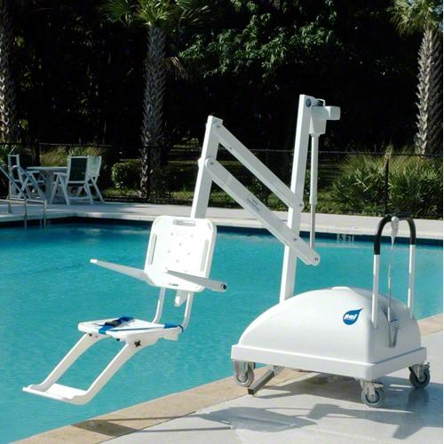Swimming pools require lifts or sloped entry. If it is not readily achievable to install a fixed lift, a business may use other means to achieve compliance, such as using a non-fixed lift.
* Saunas and steam rooms require accessible doors, turning space, and benches
* Playgrounds require accessible routes and playground equipment
* Accessible single user toilet rooms require more space for transfers
* Exercise machines must be on an accessible route surrounded by clear floor space
* Assembly areas require dispersion of accessible seating with lines of sight over standing spectators
* Washers and dryers, kitchens, and vending machines must be accessible
* Service dogs must be allowed into all areas of the hotel, without charges or conditions

# Signage and Emergency Warning Systems

* In hallways and elevators, post signs in braille and raised characters that meet guidelines of section 703 of the [2010 ADA Standards for Accessible Design](https://www.ada.gov/regs2010/2010ADAStandards/2010ADAstandards.htm#Alarm)†
* Where emergency warning systems are located, install both audible and visual alerts with alerts not to exceed 110db. Visible notification appliances must conform to the characteristics set forth by National Fire Alarm Code ([Section 7.5 of the 2002 edition](http://www.gargoylesecurity.com/004/nfpa.72.2002.pdf) or [Section 4-4 of the 1999 edition](http://www.hollistonfire.com/pdf%20files/NFPA%2072%20-%201999%20Edition.pdf). If wall-mounted, these appliances must be mounded so that the entire lens is between 2.0m and 2.4m above the finished floor. If the alarm’s sound pattern is of the T-3 variety, then a bed-shaker alert system can also be used in conjunction with the hard-wired alarm.

# Hospitality Tips

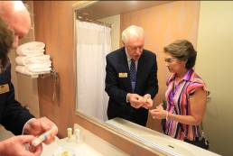To make your guests’ stay more accessible:

* Place hangers, iron, and extra pillows and blankets on the lowered closet bar, shelf, or counter in accessible rooms
* Mark shower amenities with tape or a rubber band so that guests have a tactile way to differentiate between the shampoo, conditioner, or lotion
* Lower hand held shower nozzle to bottom of sliding bar so it is within reach
* 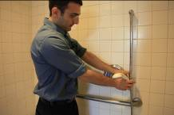Arrange furniture so it does not block access to power outlets, temperature controls, or curtain handles
* Offer room service menu, hotel directory and TV channel guide in accessible formats
* Ask guests who are blind or have low vision if they would like a tour and orientation of lobby and guest room
* Keep the lowered check-in counter clear and available for use. Do not use for brochures, computer, etc.
* Train staff to know the location of adapted equipment and how to operate the devices

* The 2010 ADA Standards for Accessible Designwent into effect on March 15, 2012. Covered entities that should have complied with the 1991 Standards during any previous construction or alteration, but had not done so by March 15, 2012, must comply with the 2010 Standards. Elements in existing facilities that comply with the 1991 Standards as of March 15, 2012, are protected by a “**safe harbor**.” These elements will not need to be changed until they are altered. Public accommodations that have existing elements that are covered for the first time under the 2010 Standards (like pools) must make those elements accessible, to an extent that is readily achievable.

† Raised character and braille elevator controls are usually required to be installed in existing facilities, because they involve little difficulty or expense and are generally considered to be readily achievable.

About Our Organization

Northwest ADA Centerprovides technical assistance, information, and training regarding the Americans with Disabilities Act. Information is provided from the regional office in Washington State and state anchors in Alaska, Idaho, and Oregon. Specialists are available to answer specific questions pertaining to all titles of the ADA and accessibility of the built environment. Training staff offer presentations to businesses, organizations, schools, people with disabilities, and the general public.

**Northwest ADA Center**

**800-949-4232 ⧫ www.nwadacenter.org**



The Northwest ADA Center is a member of the ADA National Network. This fact sheet was developed under grant from the Administration for Community Living (ACL), NIDILRR grant #90DP0016-02-00. However, the contents do not necessarily represent the policy of the ACL, and you should not assume endorsement by the federal government. **Alternate formats available upon request.**

**Northwest ADA Center** [**www.nwadacenter.org**](http://www.nwadacenter.org) **6912 220th St. SW, Suite 105, Mountlake Terrace, WA 98043**

**Toll-free: 800-949-4232 TTY: 425-771-7426 FAX: 425-774-9303 Revised 1/15/2019**