Accessibility in the Washington state Department of Corrections (Part 1)

In 2013, the Department of Corrections (DOC) in Washington state, embarked on a journey to increase accessibility in their facilities. This journey ended up being an ongoing commitment to evaluate, improve, and monitor accessibility for their incarcerated individuals and visitors.

Holly Delcambre, then ADA Compliance Manager for DOC, initially reached out to the Northwest ADA Center (NWADAC) to help develop a toolkit and action plan for conducting a system-wide ADA self-evaluation. What resulted was an ongoing partnership between the two agencies, involving multiple levels within the DOC system, to provide for systematic change in access. In this two-part series we will explore the process and results for improved facility, policy, and programmatic accessibility in the DOC.

Infrastructure Changes
The first step in change was to create the infrastructure needed to effectively manage and secure change throughout the DOC System. DOC appointed a project manager, Risa Klemme, with the goal of systematically evaluating the 12 prisons, 15 work release facilities, and the community field offices. Ms. Klemme took on the task of organizing an engaged and empowered steering committee. This includes representatives from a cross-section of DOC staff, including representatives from programs, classification, custody, policy, IT, communications mental health and health services. In addition, the Steering Committee included community members, including representatives from the Office of Deaf and Hard of Hearing, NW ADA Center, and a community member who was blind. By having a Steering Committee, matters of accessibility and ADA compliance are continuously assessed, prioritized, addressed, and re-assessed.

“We wanted a working committee that was results oriented, not a discussion group. What we did that I think was smart is that we really empowered our committee to be part of the process”- Risa Klemme, ADA Compliance Manager

Assessment
Accessibility Site Surveys: Teams were formed for each site survey, comprised of staff from NWADAC, steering committee members, the facility ADA Coordinator, and the facility plant manager. These teams went out to each facility and conducted the survey, each taking 3-4 days, in each of the 12 correctional facilities, including parking, program services, restrooms, food service areas, living units, accessible cells/rooms libraries/classrooms, and assembly areas. The NWADAC developed an Accessibility Checklist for the DOC, which includes standards based upon the 2010 ADA Standards for Accessible Design and Washington State Building Code.

Successful Outcomes:

- A number of themes emerged from the survey, including issues with reach range, protruding objects, inadequate space for wheelchairs, uneven surfaces, inadequate signage, and ramps that were too steep.

 | BEFORE |  | AFTER
Running slope of ramp was too high | 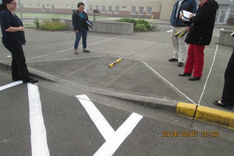 | Running slope of ramp now 8.3°. Access way re-striped to align with new curb cut | 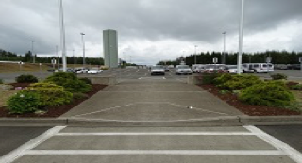
The picnic tables for the Extended Family Visit Units were not in an accessible path and were not an accessible design. | 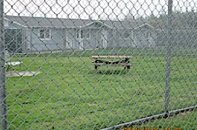 | Picnic tables moved to a poured concrete pad and changed to an accessible design. | 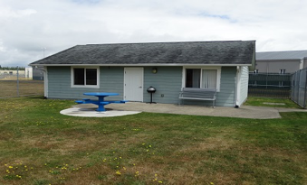
The changing station was 57” high when closed. The garbage can also blocked the path to the changing table. | 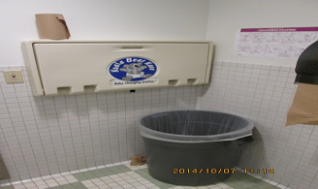 | The garbage can was moved. The changing table was lowered on the wall so that it was no more than 48” to the handle. | 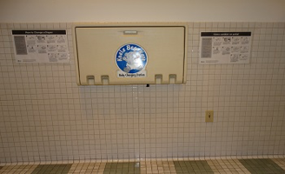
Several of the vending machines in the visiting room were 54” to the highest operable part | 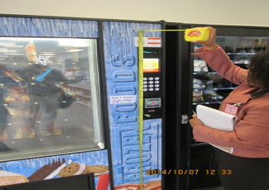 | We worked with our vendor to bring in vending machines that were accessible and no more than 48” to the highest control or operable part. | 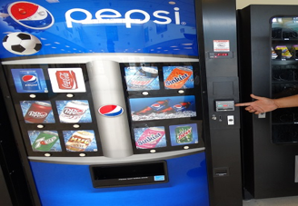

- KIOSKS for offender use (intranet system) were inaccessible to incarcerated individuals with disabilities who had low vision/blindness, hand function issues, or who used wheelchairs. As a result of our survey, Correctional Industries will work with our IT Department to the KIOSK to make it more accessible.

- Participation in surveys by facility ADA Coordinators, plant managers, and steering committee members provided hands-on training and enhanced understanding of accessibility standards.

- Secondary egress routes were assessed and accessibility plans developed to mitigate issues and ensure accessibility.
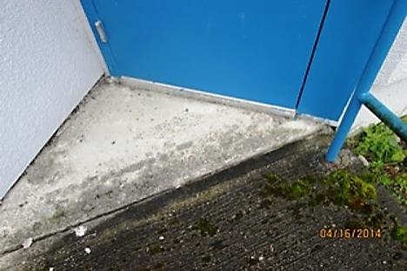 | 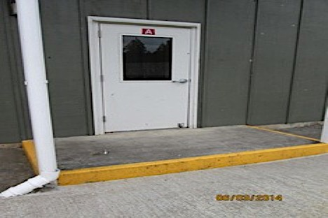
Inaccessible emergency egress routes

- Washington state DOC became a model for other systems in the country, with Department of Homeland Security (DHS) and Immigration and Customs Enforcement (ICE) ultimately coming to Washington to participate in an ADA self-assessment.

Keys to Success:
-An engaged, empowered Steering Committee with representatives from all aspects of the DOC to guide the project, make recommendations, and spur change
-A dedicated project manager who managed the project from start to finish
-Training for ADA Coordinators and plant managers at each site
-Developing a relationship with NW ADA for needed technical expertise
-Buy-in to the process from executive leadership on down was crucial to the success of this project!

“-The project provided a monumental opportunity to provide formal and informal training to a wide-array of staff members on disability matters. This included all levels of management including facility superintendents and community corrections supervisors, plant managers, ADA coordinators and provided an opportunity to raise awareness of line staff concerning disability issues.” Rise Klemme, ADA Compliance Manager

(For more information, see Part 2 of this story on increasing policy and programmatic access for people with disabilities at WA state DOC)

