Community Partnerships Create a
Universal Garden in Boise, ID
We would like to share a wonderful story about an individual who turned the dream of an accessible garden into a reality for individuals who had believed gardening was no longer an activity that they could do.

In the spring of 2016, Christa Nuxoll, Service Coordinator at the Boise City Ada County Housing Authority, observed a resident at Shoreline Plaza gazing at their community garden. The gardening space is located at the apartment complex where Nuxoll works and where the resident lives; it’s a low-income, high-rise residential building for residents 62 years and older and individuals with disabilities. This resident expressed her disappointment that the pathways to the garden were too difficult for her to access because of her mobility disabilities.

This resident inspired Nuxoll to think about the many residents who missed gardening because of the barriers in the current garden space. She started brainstorming ways to create a garden that would be accessible to all residents who would like to enjoy the activity. Nuxoll realized that if she assisted in creating an accessible garden, there would be a number of benefits, such as encouraging community through social interactions among the residents and inspiring physical exercise. A garden itself would yield healthy and delicious home-grown produce and colorful flowers.
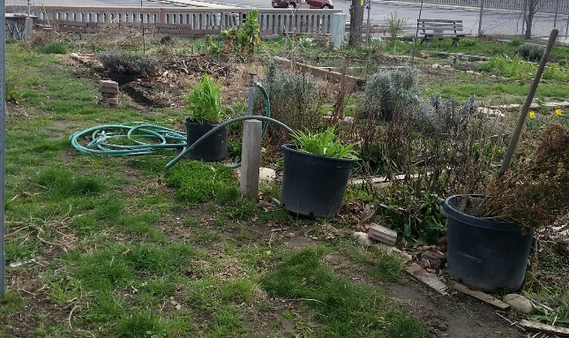
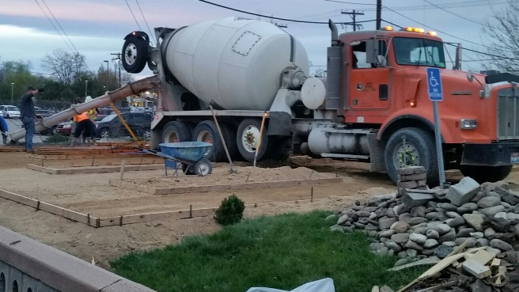
Nuxoll began by consulting with Dana Gover of the Northwest ADA Center-Idaho (NWADAC-Idaho). They discussed ideas and designs as they considered building raised garden boxes and accessible pathways in the large garden space. Although the Americans with Disabilities Act (ADA) does not specifically require garden areas to be compliant with the building code, Gover helped Nuxoll understand how to apply the 2010 ADA Standards for Accessible Design in order to create a garden that is accessible and useable for all residents, including individuals who use mobility devices, and those who have difficulty bending over, difficulty kneeling, and other disabilities.
Gover provided Nuxoll with the dimensions for accessible pathways and heights for the raised boxes, emphasizing the importance of having a level, smooth, and slip-resistant walking surface. Nuxoll organized planning meetings with the residents of the building to get their ideas and visions for a garden that they could use to grow fruit, vegetables, flowers, and herbs. She developed a plan from the meetings with information she received from the NWADAC-Idaho.
Nuxoll also contacted community partners for donations of services and materials.
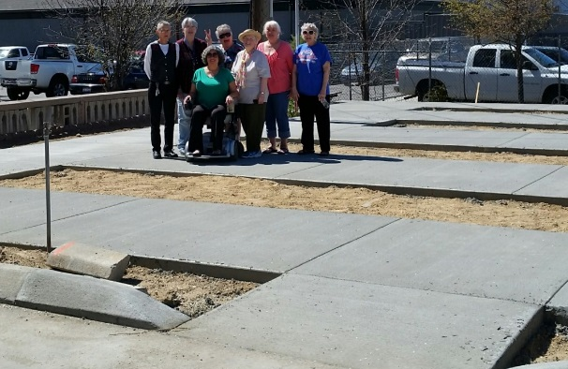
Approximately 15 community businesses and individuals came forward to make the dream of a Universal Garden become a reality. Tuffy Excavation and Idaho Materials and Construction donated materials and labor. McAlvain Construction poured the concrete pathways, and Home Depot and Rock Solid Civil provided cinder blocks, soil, tools, and starter plants. The “Universal Garden” became a reality!
Thrilled with the accessibility and inspired by the freshness of the new raised beds and walkways, the number of gardeners multiplied. The fall harvest was bountiful and residents are continuously planning their community garden for the new growing season.
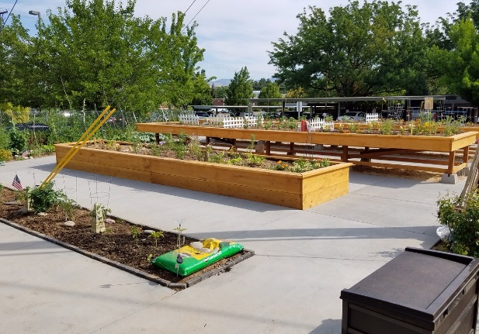
A wonderful partnership was developed between the Northwest ADA Center-Idaho and the Boise City Ada County Housing Authority, as they helped create access to gardening for 60 residents. Thank you to Deanna L. Watson, Executive Director, and Christa Nuxoll, Service Coordinator, at Boise City Ada County Housing Authority for asking NWADAC-Idaho to be involved in this community project.
If you are interested in accessible gardening, contact the Northwest ADA Center. We can also put you in touch with Christa, if you would like to learn about how she turned a dream of a Universal Garden into a community activity that creates healthy, fresh produce, gorgeous flowers, new friendships, and lots of joy and laughter. The following are pictures of the garden project, portraying the old garden, excavation stage, pouring the accessible pathways, and building the raised garden boxes to harvest.
